

Centre for Distance and Open Education
Vidya Nagari, Kalina, Santacruz East – 400098.
A Practical Journal Submitted in fulfillment
of the degree of
MASTER OF SCIENCE
IN
COMPUTER SCIENCE
YEAR 2024-25
Part II
Semester-3
Subject code – 90987R
Subject Name - Business Intelligence and
Big Data Analytics II
BY
Ms. Akshata T. Nangrey
Application ID- 37123
Seat No - 4100209

Centre for Distance and Open Education
(CDOE)
University of Mumbai
Vidya Nagari, Kalina, Santacruz East – 400098.

Certificate

This is to certify that Miss. Akshata T. Nangrey student of Masters of Computer Science, Part 2, Semester 3 has completed the specified term work in the subject of Business Intelligence and Big Data Analytics II in satisfactorily manner within this institute as laid down by University of Mumbai during the Academic year 2024 to 2025.

M.Sc. - CS Coordinator Examiner

Date: Guide

INDEX

Sr No. | Practical Name | Sign
1. | Generate regression model and interpret the result for a given data set.
2. | Generate forecasting model and interpret the result for a given data set.
3. | Write a map-reduce program to count the number of occurrences of each alphabetic character in the given dataset. The count for each letter should be case-insensitive (i.e., include both upper-case and lower-case versions of the letter; Ignore non-alphabetic characters).
4. | Write a map-reduce program to count the number of occurrences of each word in the given dataset. (A word is defined as any string of alphabetic characters appearing between non-alphabetic characters like nature's is two words. The count should be case-insensitive. If a word occurs multiple times in a line, all should be counted)
5. | Write a program to construct different types of k-shingles for given document.
6. | Write a program for measuring similarity among documents and detecting passages which have been reused.
7. | Write a program to compute the n- moment for a given stream where n is given.
8. | Write a program to demonstrate the Alon-Matias-Szegedy Algorithm for second moments.
Practical No. 1

Aim : Generate Regression model and interpret the result for a given data set.

Step 1: Open Weka then open file h.arff in Weka Explorer.
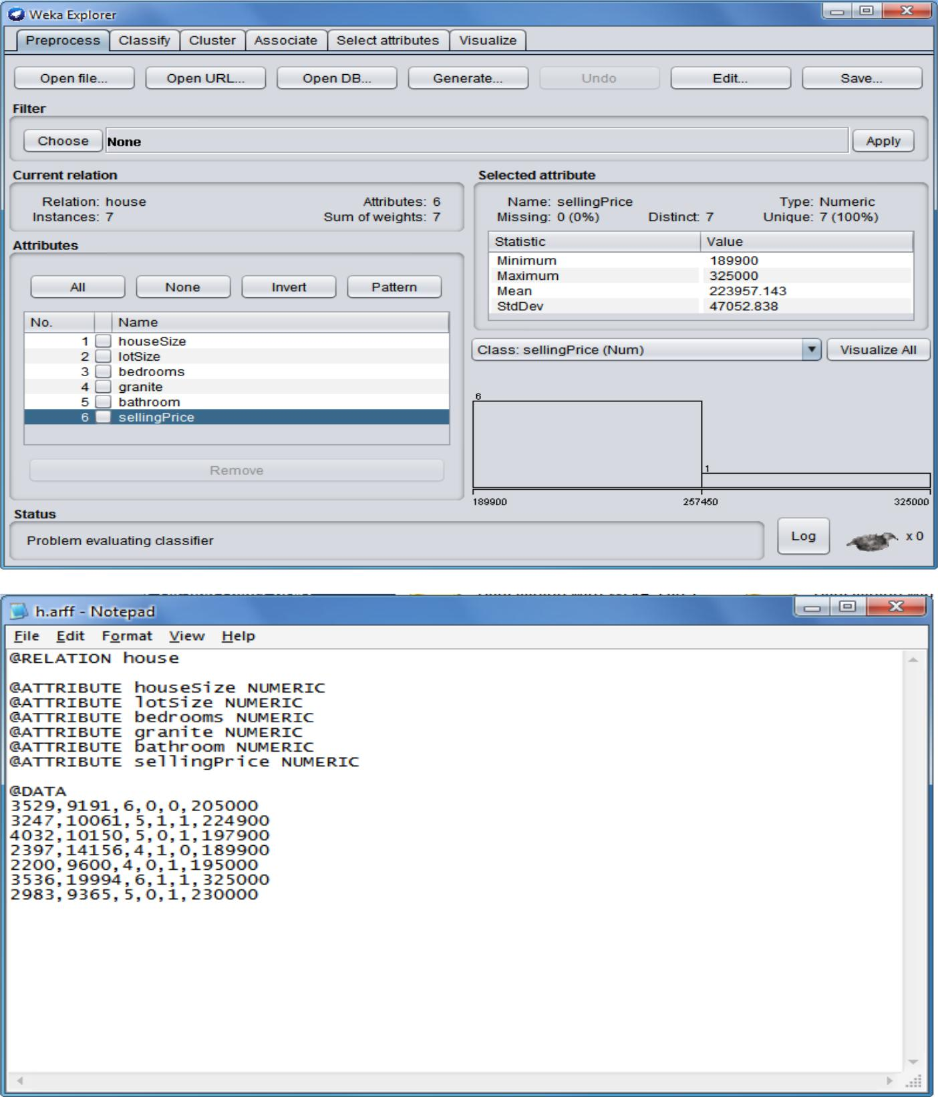

Step 2: Click on Classify, choose weka classifier function LinearRegression -S 0 -R 1.0E-8 -num-decimal-places 4.
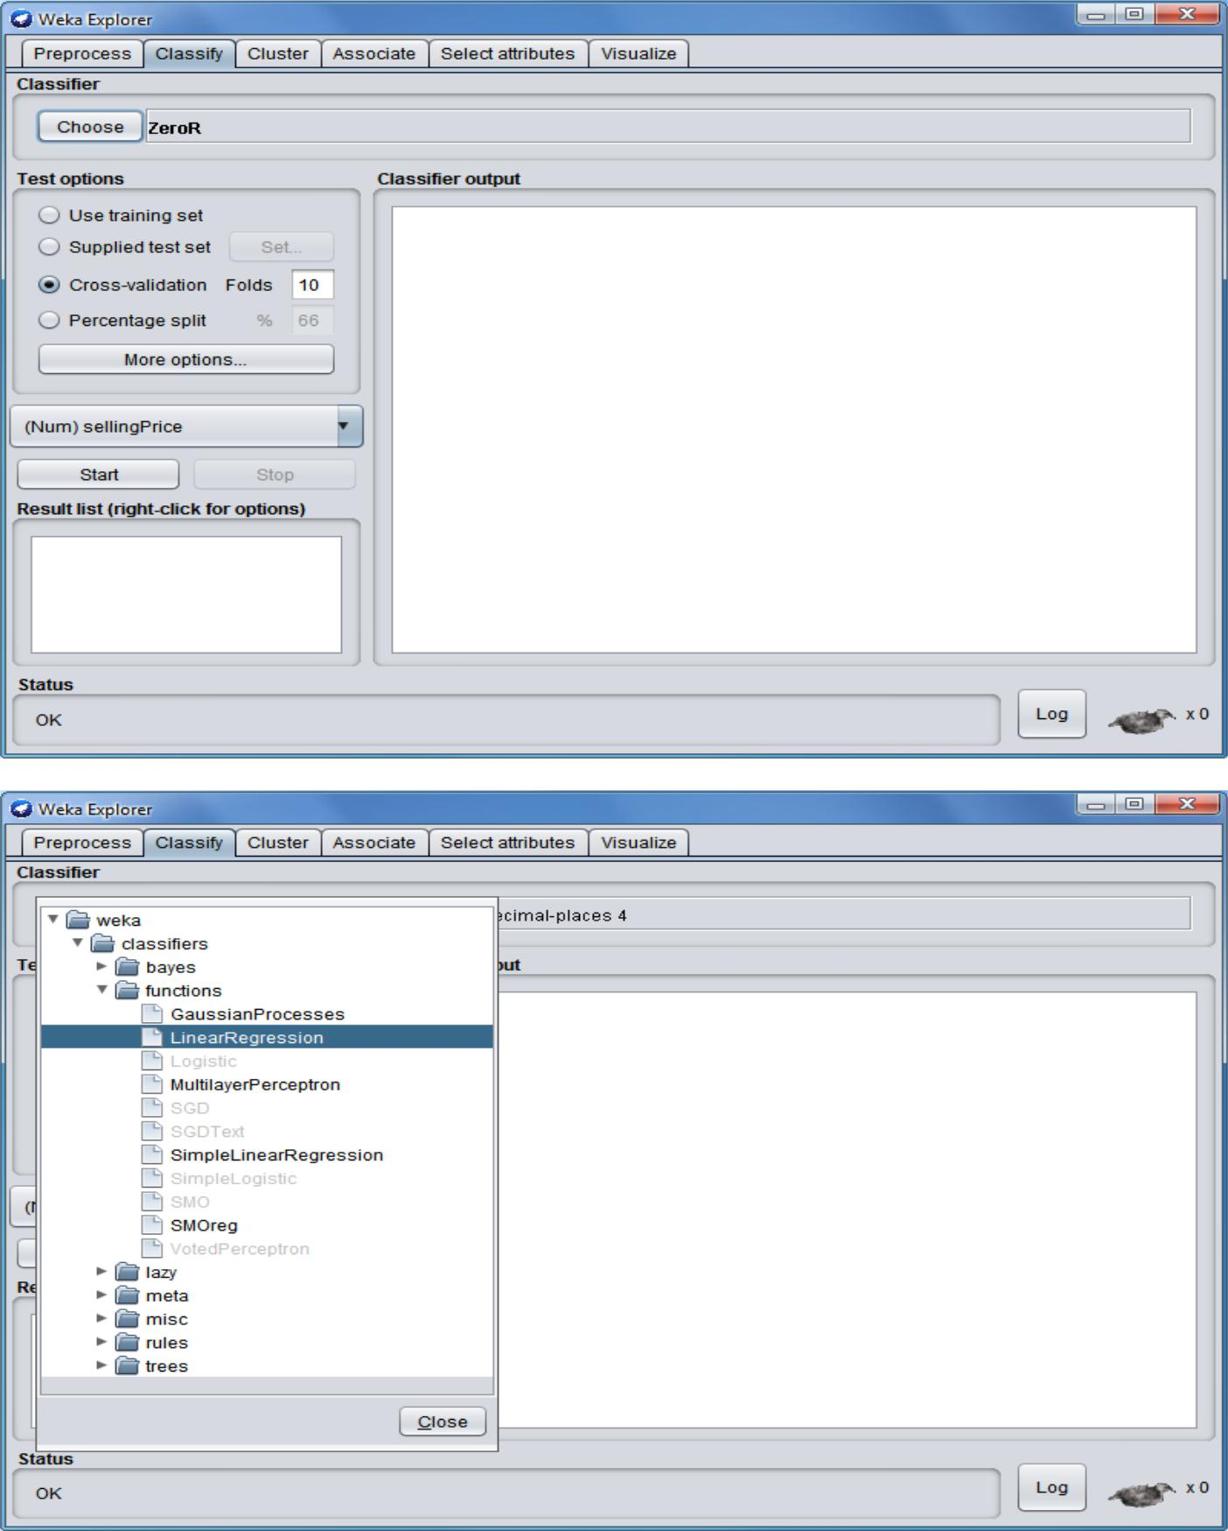
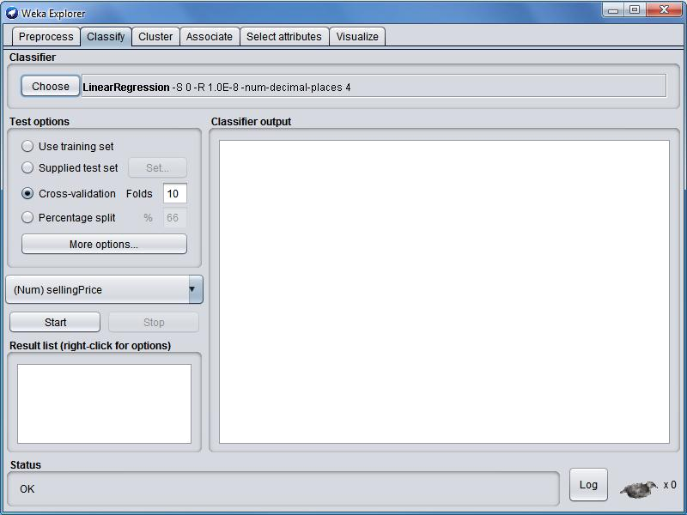

Step 3: Click on Start. You can see the linear regression on the input file.
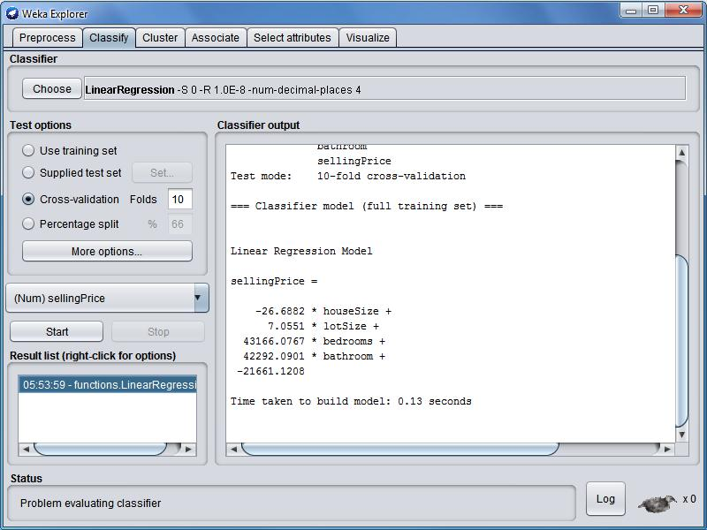
Practical No. 2

Aim : Generate forecasting model and interpret the result for a given data set.

Step 1: Open Weka then open file Weather.arff in Weka Explorer.
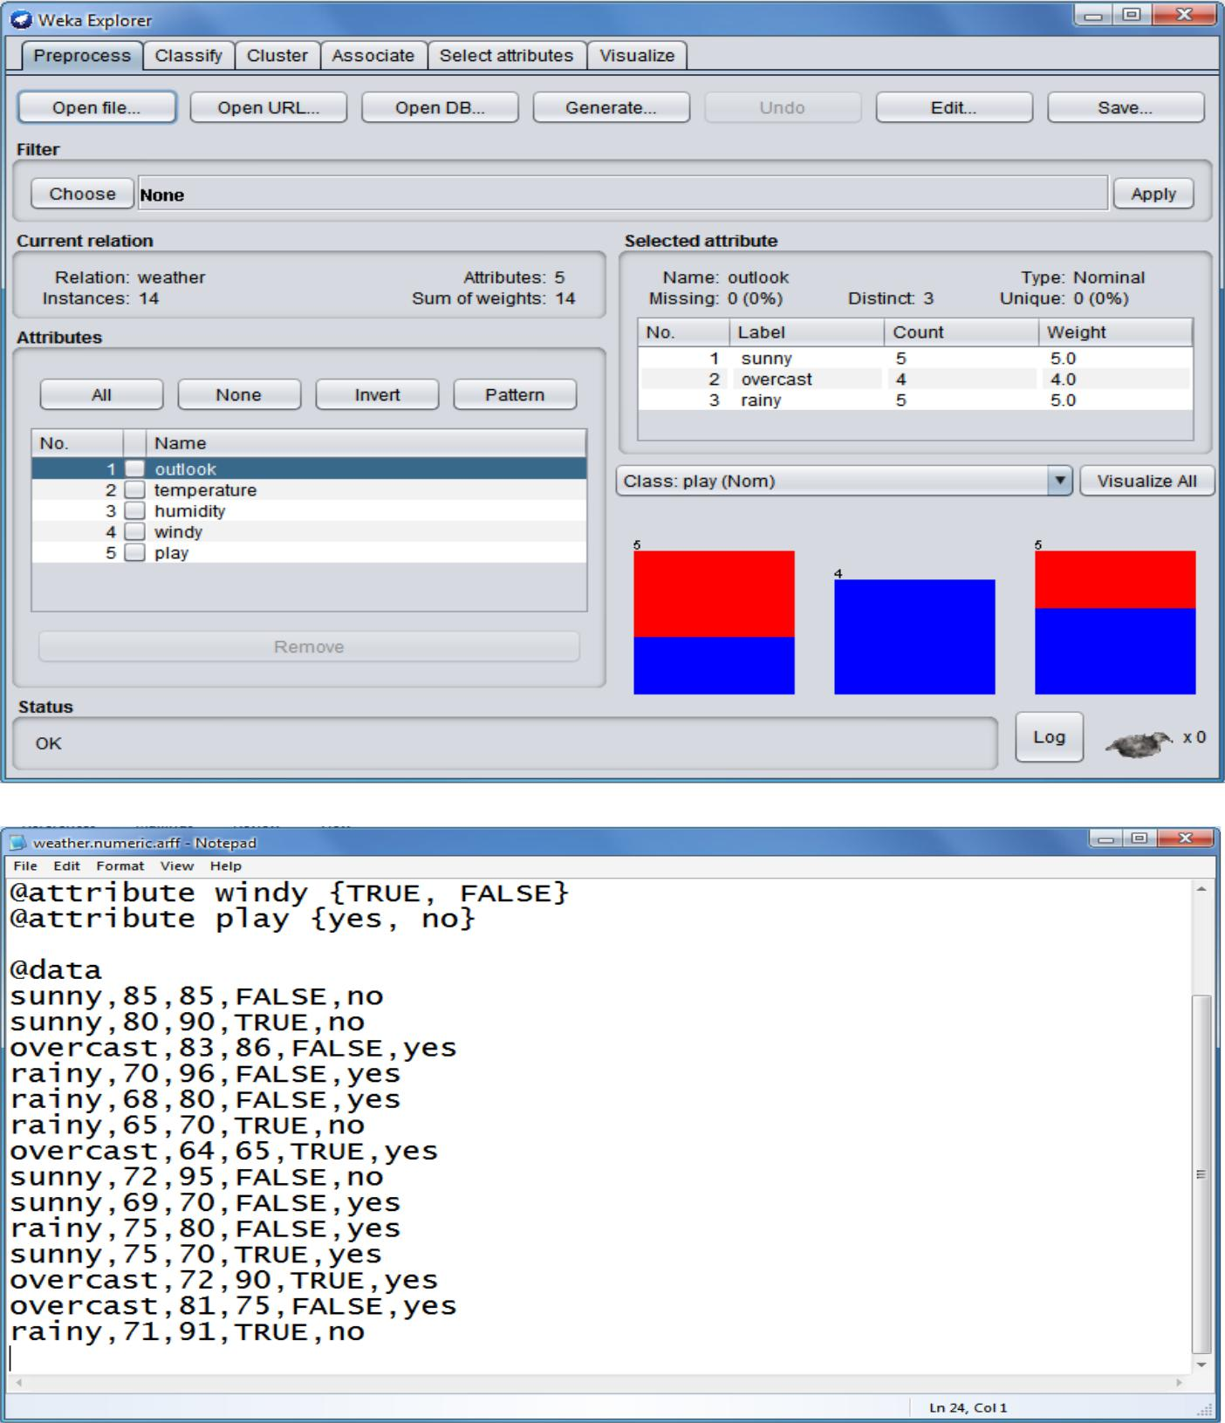

Step 2: click on Cluster, choose weka forcasting function SimpleKMean.
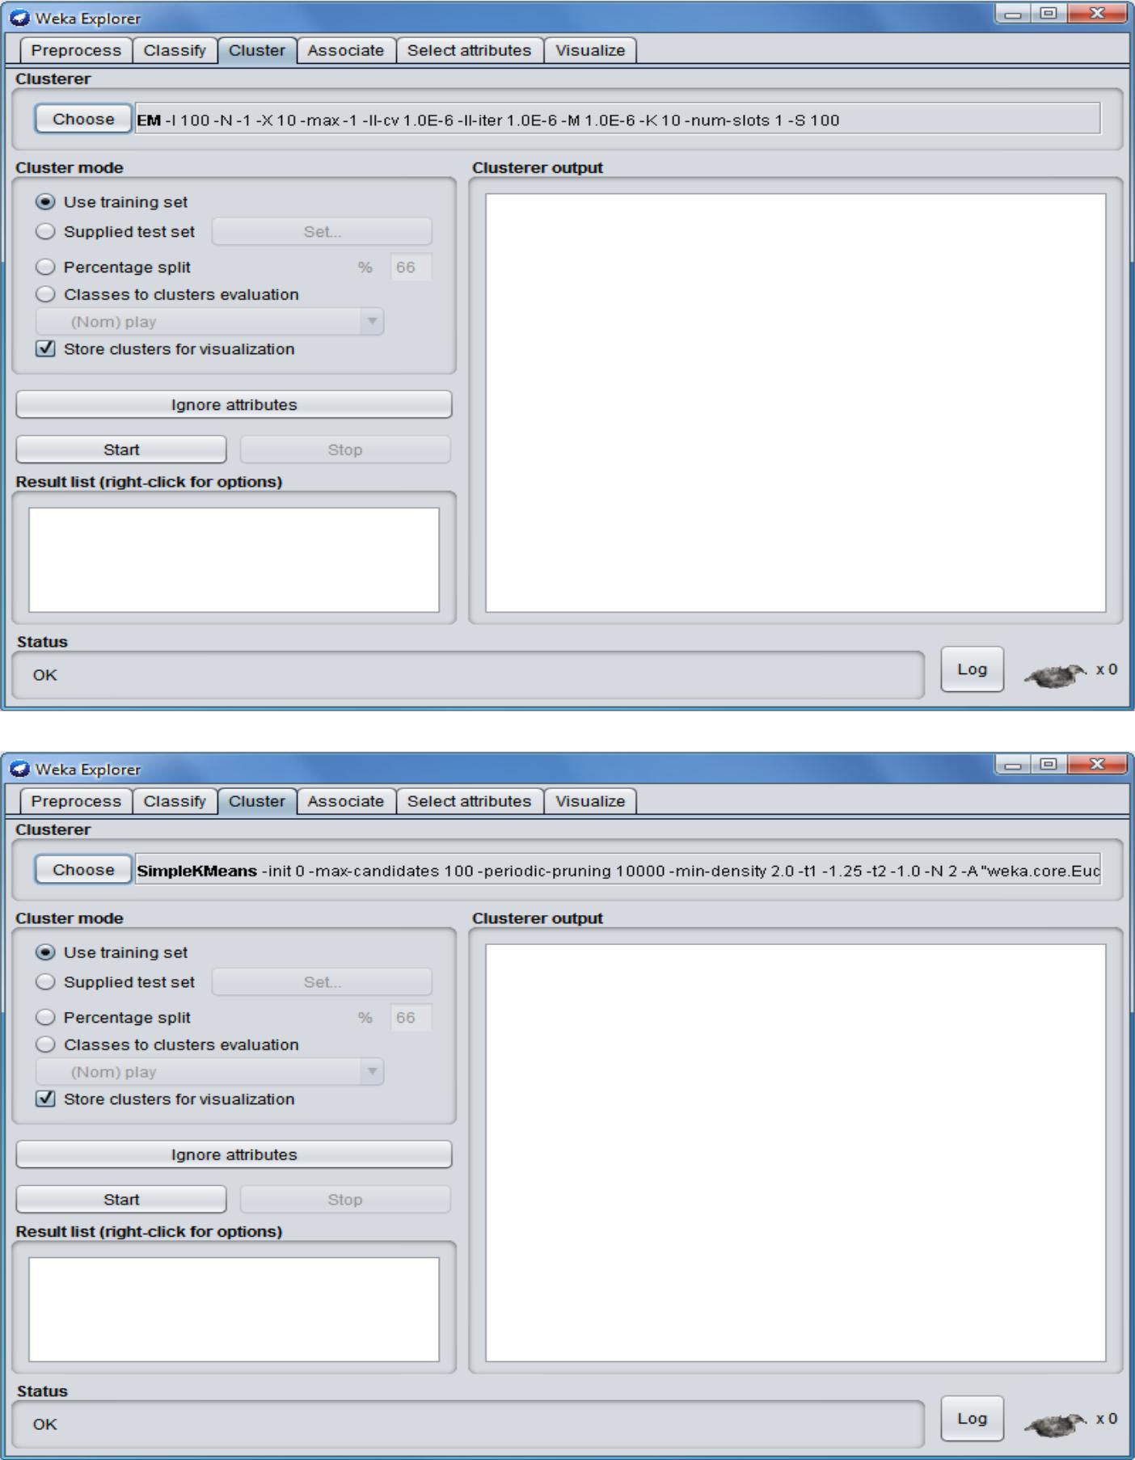
Step 3: Click on Start. You can see the SimpleKMean on the input file.
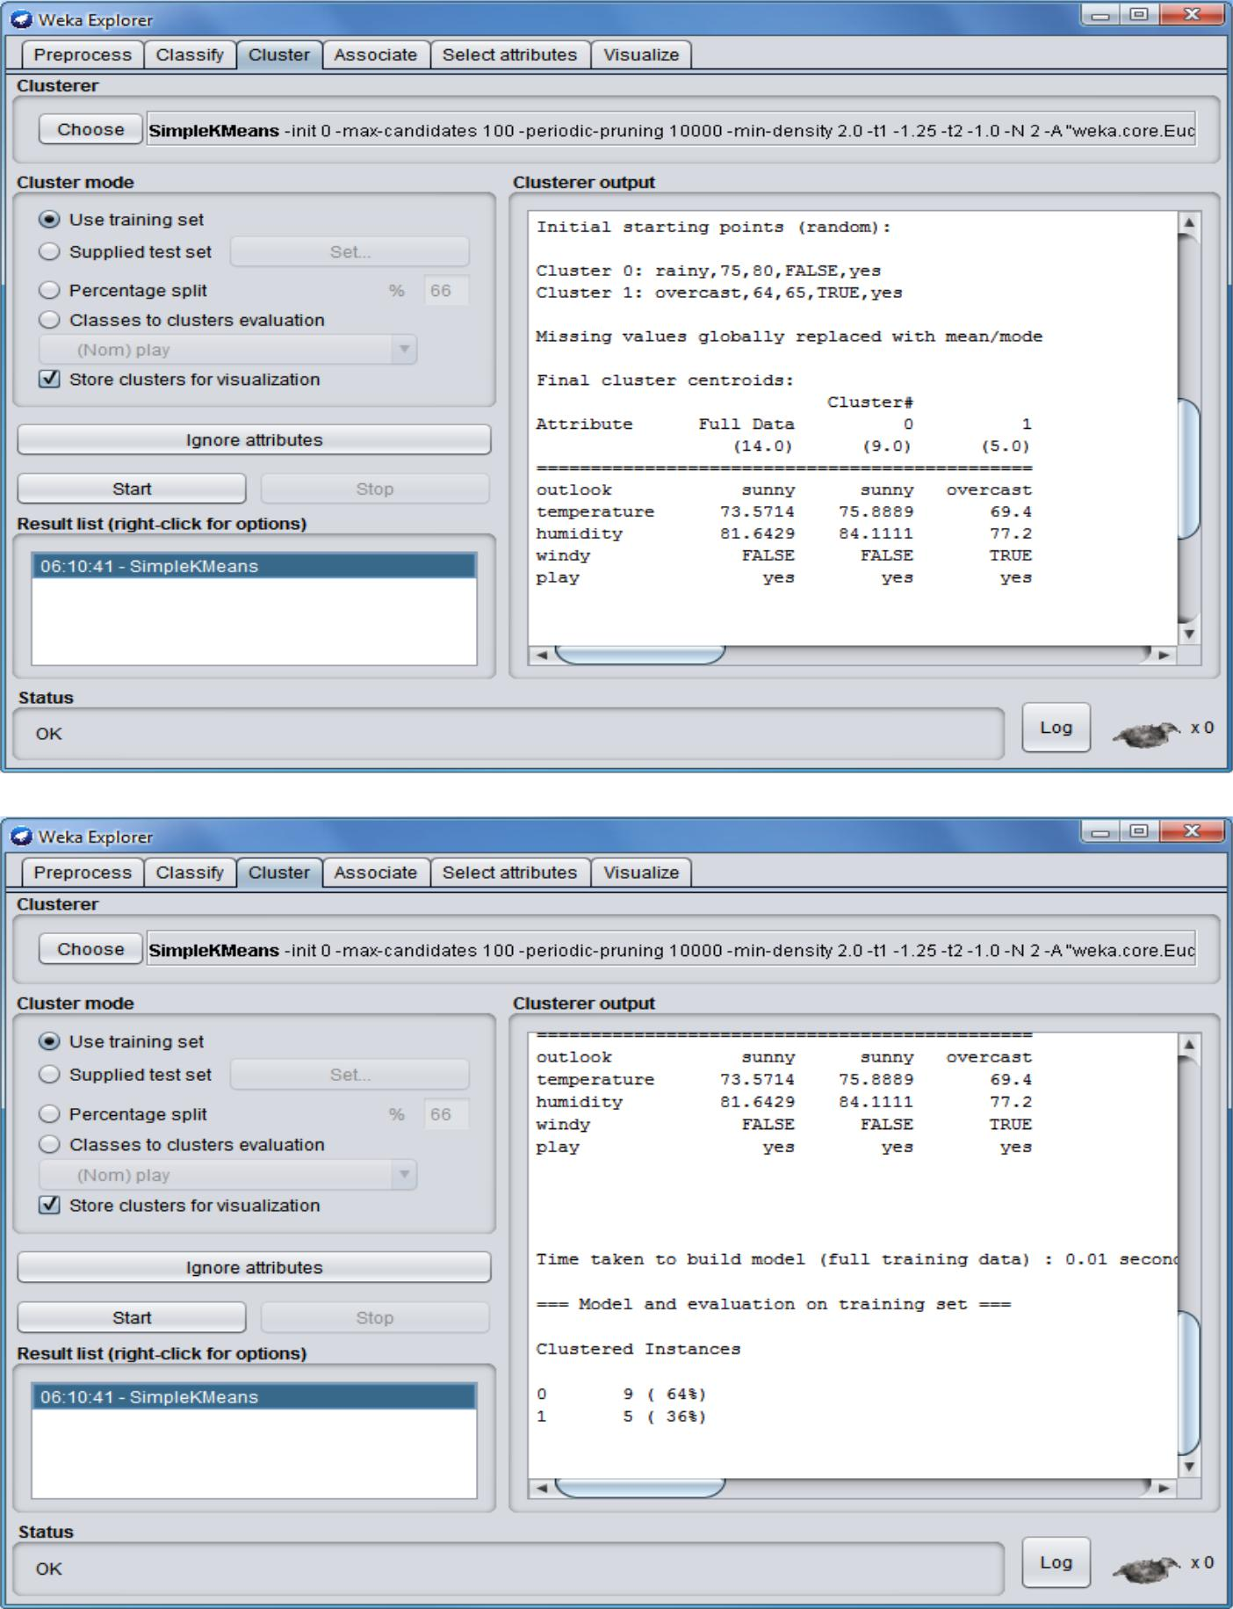
Practical No. 3

Aim : Write a map-reduce program to count the number of occurrences of each alphabetic character in the given dataset. The count for each should be case-insensitive(i.e include both upper-case and lower-case versions of the letter, ignore non-alphabetic characters).
Source Code:
Charcount.java(Driver Class)

import org.apache.hadoop.conf.Configuration; import org.apache.hadoop.fs.Path; import org.apache.hadoop.io.IntWritable;

import org.apache.hadoop.io.Text;
import org.apache.hadoop.mapreduce.Job;

import org.apache.hadoop.mapreduce.lib.input.FileInputFormat; import org.apache.hadoop.mapreduce.lib.input.TextInputFormat; import org.apache.hadoop.mapreduce.lib.output.FileOutputFormat; import org.apache.hadoop.mapreduce.lib.output.TextOutputFormat;

public class Charcount {

public static void main(String[] args) throws Exception {

- TODO Auto-generated method stub Configuration conf = new Configuration(); Job job = new Job(conf, "Charcount"); job.setJarByClass(Charcount.class); job.setMapperClass(Charmap.class); job.setReducerClass(Charreduce.class); job.setInputFormatClass(TextInputFormat.class); job.setOutputFormatClass(TextOutputFormat.class); job.setMapOutputKeyClass(Text.class); job.setMapOutputValueClass(IntWritable.class); job.setOutputKeyClass(Text.class); job.setOutputValueClass(IntWritable.class); FileInputFormat.addInputPath(job, new Path(args[0]));
FileOutputFormat.setOutputPath(job, new Path(args[1])); System.exit(job.waitForCompletion(true) ? 0 : 1);

}

}

Charmap.java(Mapper Class)

import java.io.IOException;
import java.util.StringTokenizer;

import org.apache.hadoop.io.IntWritable;
import org.apache.hadoop.io.LongWritable;
import org.apache.hadoop.io.Text;

import org.apache.hadoop.mapreduce.Mapper;

public class Charmap extends Mapper<LongWritable, Text, Text, IntWritable> { public void map(LongWritable key, Text value, Context context)

throws IOException, InterruptedException {

String line = value.toString();
char[] carr = line.toCharArray();

for (char c : carr) {
System.out.println(c);
context.write(new Text(String.valueOf(c)), new IntWritable(1));
}

}

}
Charreduce.java(Reducer Class)

import java.io.IOException;

import org.apache.hadoop.io.IntWritable;
import org.apache.hadoop.io.Text;
import org.apache.hadoop.mapreduce.Reducer;

public class Charreduce extends Reducer<Text, IntWritable, Text, IntWritable> { public void reduce(Text key,Iterable<IntWritable> values,Context context)throws
IOException,InterruptedException{
int count = 0;

IntWritable result = new IntWritable();
for (IntWritable val : values) {
count +=val.get();
result.set(count);

}
String found = key.toString();
if (found.equals("a") || found.equals("t") || found.equals("c") || found.equals("g"))
{

context.write(key, result);
}

}
}
Practical No. 4
Aim : Write a map-reduce program to count the number of occurrences of each word in the given dataset.(A word is defined as any string of alphabetic characters appearing between non-alphabetic characters like nature’s is two words. The count should be case-insensitive. If a word occurs multiple times in a line, all should be counted).

WordCount.java(Driver Class)

import org.apache.hadoop.fs.Path;
import org.apache.hadoop.conf.*;
import org.apache.hadoop.io.*;
import org.apache.hadoop.mapred.*;
import org.apache.hadoop.util.*;

public class WordCount extends Configured implements Tool{ public int run(String[] args) throws Exception

{

//creating a JobConf object and assigning a job name for identification purposes

JobConf conf = new JobConf(getConf(), WordCount.class); conf.setJobName("WordCount");

//Setting configuration object with the Data Type of output Key and Value
conf.setOutputKeyClass(Text.class);
conf.setOutputValueClass(IntWritable.class);

//Providing the mapper and reducer class names conf.setMapperClass(WordCountMapper.class); conf.setReducerClass(WordCountReducer.class);

//We wil give 2 arguments at the run time, one in input path and other is output

path
Path inp = new Path(args[0]);
Path out = new Path(args[1]);

//the hdfs input and output directory to be fetched from the command line FileInputFormat.addInputPath(conf, inp); FileOutputFormat.setOutputPath(conf, out);

JobClient.runJob(conf);
return 0;
}

public static void main(String[] args) throws Exception
{
// this main function will call run method defined above.

int res = ToolRunner.run(new Configuration(), new WordCount(),args); System.exit(res);

}
}

WordCountMapper.java(Mapper Class)

import java.io.IOException;
import java.util.StringTokenizer;

import org.apache.hadoop.io.*;
import org.apache.hadoop.mapred.*;

public class WordCountMapper extends MapReduceBase implements Mapper<LongWritable, Text, Text, IntWritable> {

//hadoop supported data types

private final static IntWritable one = new IntWritable(1); private Text word = new Text();

//map method that performs the tokenizer job and framing the initial key value pairs

// after all lines are converted into key-value pairs, reducer is called.

public void map(LongWritable key, Text value, OutputCollector<Text, IntWritable> output, Reporter reporter) throws IOException

{

//taking one line at a time from input file and tokenizing the same String line = value.toString();

StringTokenizer tokenizer = new StringTokenizer(line);

//iterating through all the words available in that line and forming the key value

pair
while (tokenizer.hasMoreTokens())

{
word.set(tokenizer.nextToken());

//sending to output collector which inturn passes the same to reducer output.collect(word, one);

}
}
}

WordCountReducer.java(Reducer Class)

import java.io.IOException;
import java.util.Iterator;

import org.apache.hadoop.io.*;
import org.apache.hadoop.mapred.*;

public class WordCountReducer extends MapReduceBase implements Reducer<Text,

IntWritable, Text, IntWritable>
{

//reduce method accepts the Key Value pairs from mappers, do the aggregation based on keys and produce the final out put

public void reduce(Text key, Iterator<IntWritable> values, OutputCollector<Text, IntWritable> output, Reporter reporter) throws IOException

{
int sum = 0;

/*iterates through all the values available with a key and add them together and give the

final result as the key and sum of its values*/ while (values.hasNext()) {

sum += values.next().get();

}
output.collect(key, new IntWritable(sum));
}
}
Practical No. 5

Aim :Write a program to construct different types of k-shingles for given document.
Installation of required packages before executing program:-

install.packages("tm")
require("tm")
install.packages("devtools")

readinteger <- function()

{

- <- readline(prompt="Enter value of k-1: ") k<-as.integer(n)

u1 <- readLines(E:/BA/Hadoop.txt”) Shingle<-0

i <-0 while(i<nchar(u1)-k+1)
{

Shingle[i] <- substr(u1, start=i, stop=i+k) print(Shingle[i])

i=i+1
}

}
if(interactive()) readinteger()
OutPut:-

- if(interactive()) readinteger() Enter value of k-1: 2 character(0)
[1] "thi"
[1] "his"
[1] "is "
[1] "s i"
[1] " is"
[1] "is "
[1] "s a"
[1] " a "
[1] "a t"
[1] " te"
[1] "tex"
[1] "ext"
[1] "xt."

OutPut:-

- if(interactive()) readinteger() Enter value of k-1: 3 character(0)
[1] "this"
[1] "his "
[1] "is i"
[1] "s is"
[1] " is "

[1] "is a"
[1] "s a "
[1] " a t"
[1] "a te"

OutPut:-

- if(interactive()) readinteger() Enter value of k-1: 4 character(0)
[1] "this "
[1] "his i"
[1] "is is"
[1] "s is "
[1] " is a"
[1] "is a "
[1] "s a t"
[1] " a te"
[1] "a tex"
[1] " text"
[1] "text."
[1] "ext. "
Practical No. 6
Aim : Write a program for measuring similarity among documents and detecting passages which have been reused.

Installation of required packages before executing program:-

install.packages("tm")
require("tm")

install.packages("ggplot2")
install.packages("textreuse")
install.packages("devtools")

Source Code 1:-

my.corpus <- Corpus(DirSource("c:/msc/r-corpus"))

my.corpus <- tm_map(my.corpus, removeWords, stopwords("english"))
my.tdm <- TermDocumentMatrix(my.corpus)
#inspect(my.tdm)
my.dtm <- DocumentTermMatrix(my.corpus, control = list(weighting =

weightTfIdf, stopwords = TRUE))
#inspect(my.dtm)
my.df <- as.data.frame(inspect(my.tdm))
my.df.scale <- scale(my.df)

- <- dist(my.df.scale,method="euclidean") fit <- hclust(d, method="ward") plot(fit)
OutPut:-

<<TermDocumentMatrix (terms: 69, documents: 6)>>
Non-/sparse entries: 97/317
Sparsity : 77%
Maximal term length: 12
Weighting : term frequency (tf)
Docs
Terms | File1.txt File2.txt File3.txt File4.txt File5.txt File6.txt
also | 0 | 1 | 1 | 1 | 0 | 0
bed | 0 | 0 | 0 | 1 | 0 | 0
better | 0 | 0 | 0 | 1 | 0 | 0
call | 0 | 1 | 0 | 0 | 0 | 0
can | 0 | 0 | 1 | 1 | 0 | 0
cat | 0 | 0 | 0 | 1 | 0 | 0
cats | 0 | 0 | 0 | 1 | 0 | 0
couch. | 0 | 0 | 0 | 1 | 0 | 0

- barplot(as.matrix(my.tdm))
- my.df.scale <- scale(my.df)
- d <- dist(my.df.scale,method="euclidean")
- fit <- hclust(d, method="ward")

The "ward" method has been renamed to "ward.D"; note new "ward.D2" > plot(fit)
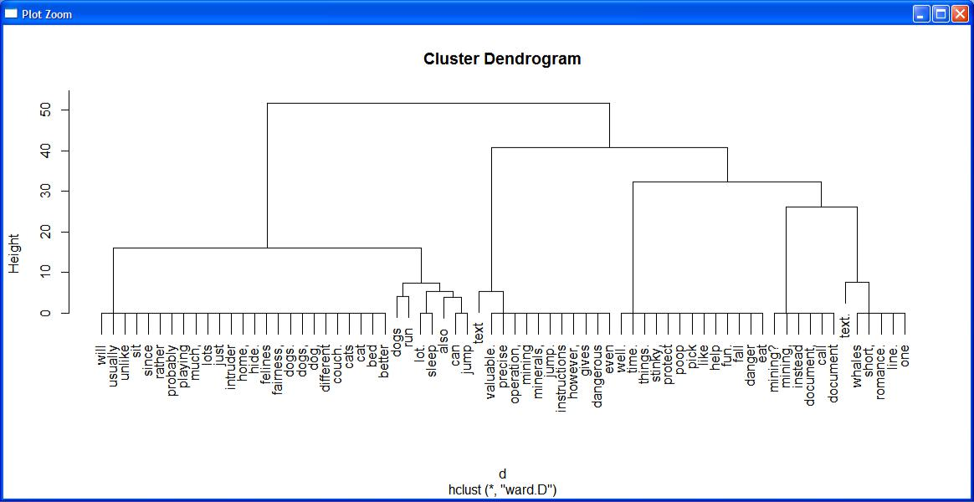

Sourec code 2 (using bar plot with and without color):-

my.corpus <- Corpus(DirSource("c:/msc/r-corpus"))

my.corpus <- tm_map(my.corpus, removeWords, stopwords("english"))
my.tdm <- TermDocumentMatrix(my.corpus)

inspect(my.tdm)
my.df <- as.data.frame(inspect(my.tdm))
barplot(as.matrix(my.tdm))
#barplot(as.matrix(my.tdm),col = color)

OutPut:-
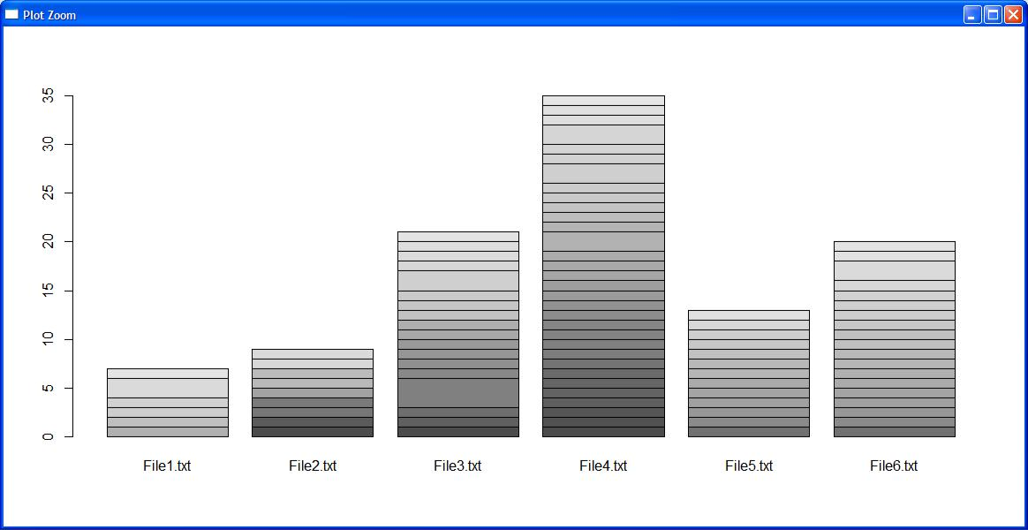

barplot(as.matrix(my.tdm),col = color)
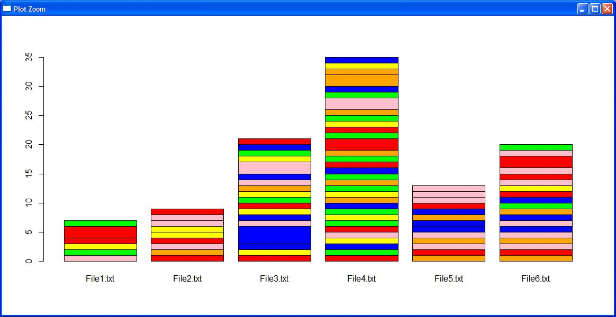

Jaccard similarity

Similarity of asymmetric binary attributes[edit]

Given two objects, A and B, each with n binary attributes, the Jaccard coefficient is a useful measure of the overlap that A and Bshare with their attributes. Each attribute of A and B can either be 0 or 1. The total number of each combination of attributes for both A and B are specified as follows:

represents the total number of attributes where A and B both have a value of 1.

represents the total number of attributes where the attribute of A is 0 and the attribute of B is 1.

represents the total number of attributes where the attribute of A is 1 and the attribute of B is 0.

represents the total number of attributes where A and B both have a value of 0.

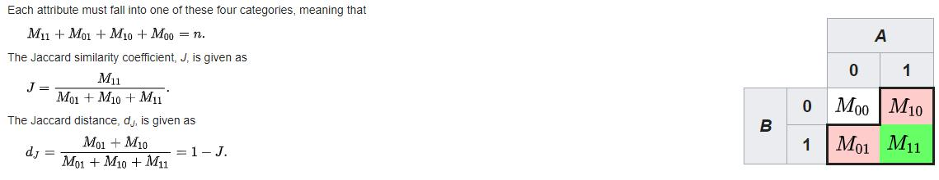

Sourec code 3 (using minhash and jaccard similarity):-

library(textreuse)

Source Code:-

minhash <- minhash_generator(200, seed = 235)

ats <- TextReuseCorpus(dir = "c:/msc/r-corpus", tokenizer = tokenize_ngrams, n = 5, minhash_func = minhash)

buckets <- lsh(ats, bands = 50, progress = interactive())
candidates <- lsh_candidates(buckets)
scores <- lsh_compare(candidates, ats, jaccard_similarity, progress = FALSE) scores

color <- c("red","green","blue","orange","yellow","pink")

barplot(as.matrix(scores),col = color)

Output:
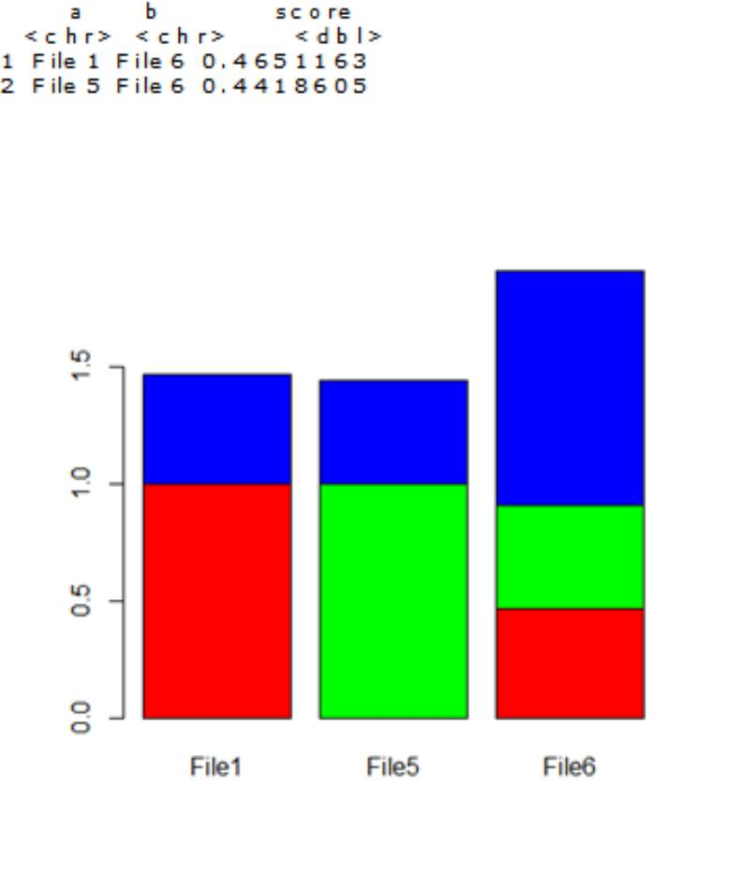

Practical No. 7

Aim : Write a program to compute the n-moment for a given stream where n is given.

Source Code:

import java.io.*;
import java.util.*;

class n_moment2
{
public static void main(String args[])
{

int n=15;
String stream[]={"a","b","c","b","d","a","c","d","a","b","d","c","a","a","b"};

int zero_moment=0,first_moment=0,second_moment=0,count=1,flag=0; ArrayList<Integer> arrlist=new ArrayList();;

System.out.println("Arraylist elements are :: ");

for(int i=0;i<15;i++)
{
System.out.print(stream[i]+" ");
}

Arrays.sort(stream);

//Calculate Zeroth moment(calculates unique elements-raised to zero)
for(int i=1;i<n;i++)
{

if(stream[i]==stream[i-1])
{
count++;
}

else
{
arrlist.add(count);
count=1;

}
}
arrlist.add(count);

zero_moment=arrlist.size();
System.out.println("\n\n\nValue of Zeroth moment for given stream ::"+zero_moment);

//Calculate First moment(Calculate length of the stream-raised to one)

for(int i=0;i<arrlist.size();i++)
{
first_moment+=arrlist.get(i);
}
System.out.println("\n\nValue of First moment for given stream ::"+first_moment);

//Calculate Second moment(raised to two)
for(int i=0;i<arrlist.size();i++)
{

int j=arrlist.get(i);
second_moment+=(j*j);
}
System.out.println("\n\nValue of Second moment for given stream ::"+second_moment);

}
}

Output :

Arraylist elements are ::
a b c b d a c d a b d c a a b

Value of Zeroth moment for given stream ::4

Value of First moment for given stream ::15

Value of Second moment for given stream ::59

Practical No. 8

Aim : Write a program to demonstrate the Alon-Matias-Szegedy Algorithm for second moments.

Source Code:

import java.io.*;

import java.util.*;
class AMSA
{

public static int findCharCount(String stream,char XE,int random,int n)

{

int countOccurance=0;

for(int i=random;i<n;i++)

{

if(stream.charAt(i)==XE)

{

countOccurance++;//System.out.println(countOccurance+" "+i);

}

}

return countOccurance;

}

public static int estimateValue(int XV1,int n)

{

int ExpValue;

ExpValue=n*(2*XV1-1);

return ExpValue;

}

public static void main(String args[])

{

int n=15;

String stream="abcbdacdabdcaab";

int random1=3,random2=8,random3=13;

char XE1,XE2,XE3;

int XV1,XV2,XV3;

int ExpValuXE1, ExpValuXE2, ExpValuXE3;

int apprSecondMomentValue;
XE1=stream.charAt(random1-1);
XE2=stream.charAt(random2-1);

XE3=stream.charAt(random3-1);

//System.out.println(XE1+" "+XE2+" "+XE3);

XV1=findCharCount(stream,XE1,random1-1,n);

XV2=findCharCount(stream,XE2,random2-1,n);

XV3=findCharCount(stream,XE3,random3-1,n);

System.out.println(XE1+"="+XV1+" "+XE2+"="+XV2+" "+XE3+"="+XV3);

ExpValuXE1=estimateValue(XV1,n);

ExpValuXE2=estimateValue(XV2,n);

ExpValuXE3=estimateValue(XV3,n);

System.out.println("Expected value for "+XE1+" is :: "+ExpValuXE1);

System.out.println("Expected value for "+XE2+" is :: "+ExpValuXE2);

System.out.println("Expected value for "+XE3+" is :: "+ExpValuXE3);

apprSecondMomentValue=(ExpValuXE1+ExpValuXE2+ExpValuXE3)/3;

System.out.println("Approximate Second moment value using Alon-Matias-Szegedy is :: "+apprSecondMomentValue);

}

}

Output:

c=3 d=2 a=2

Expected value for c is :: 75

Expected value for d is :: 45

Expected value for a is :: 45

Approximate Second moment value using Alon-Matias-Szegedy is :: 55

